UNIVERSITY OF HERTFORDSHIRE

HATFIELD, 2025

7COM1079-0901-2025
Team Research and Development Project

Report title

Has the unemployment rate across U.S. metropolitan statistical areas significantly decreased from January 1990 to November 2016?
A paired longitudinal analysis of 394 metropolitan areas using BLS LAUS data

Group ID:

Dataset number:

Prepared by:

Table of Contents
1. Introduction 3
1.1 Problem statement and research motivation 3
1.2 The data set 3
1.3 Research question 3
1.4 Research Hypothesis (H0/H1) 3
2. Background research 4
2.1 Research papers 4
2.2 Why RQ is of interest (research gap and future directions according to the literature) 4
2.3 Visualisation 5
2.3.1 Appropriate graphs for the RQ 5
2.3.2 Useful information for the data understanding 6
3. Analysis 6
3.1 Statistical test used to test the hypotheses and output 6
3.2 The null hypothesis is rejected based on the p-value 7
4. Evaluation – group’s experience at 7COM1079 7
4.1 What went well 7
4.2 Points for improvement 7
4.3 Group’s time management 7
4.4 Project’s overall judgement 7
4.5 Comment on the GitHub log output 7
5. Conclusions 8
5.1 Results explained 8
5.2 Interpretation of the results 8
5.3 Implications for future work 8
6. Reference List 9
7. Appendices 10
R code used for analysis and visualisation 10
GitHub log output 12

1. Introduction

1.1 Problem statement and research motivation
High unemployment in the long term has significant economic and social burdens such as lost output, decreased tax revenues and greater inequality. The question of whether U.S. metropolitan labour markets returned to pre-1990s levels following several recessions (1990-91, 2001, 2007-09) is essential in determining macroeconomic resilience over the long term and the success of stabilisation policies (Blanchard and Katz, 1992). As the U.S. has been undergoing the longest period in its history of growth as of 2016, exploring whether average unemployment has gone back to or below the levels of the early 1990s gives a valuable indicator of the normalisation of labour markets.

1.2 The data set
The U.S. Bureau of Labor Statistics dataset Unemployment rates by "Unemployment rates by Metropolitan Statistical Area 1990-2016.xlsx" has monthly observations of 394 metropolitan areas (including NECTAs and Puerto Rico) in the period between January 1990 and November 2016. The " All Years & Months" sheet contains 127,262 rows with three key variables: Area, Year, Month, Civilian Labor Force, Employment, Unemployment and Unemployment rate %.
Link to the dataset: https://data.world/garyhoov/unemployment-rate-by-city

1.3 Research question
Has the mean unemployment rate across U.S. Metropolitan Statistical Areas significantly decreased from January 1990 to November 2016?

1.4 Research Hypothesis (H0/H1)
- H₀: There is no difference in the median unemployment rate between January 1990 and November 2016 (μ₁₉₉₀ = μ₂₀₁₆).
- H₁: The median unemployment rate in November 2016 is lower than in January 1990 (μ₂₀₁₆ < μ₁₉₉₀).
A one-tailed Wilcoxon signed-rank test is employed since each of the 394 metropolitan areas has a paired observation and the differences cannot be normally distributed (Shapiro–Wilk p < 2.2×10⁻¹⁶) so a non-parametric paired test is the most suitable option.

2. Background research

2.1 Research papers
The dataset is based on the U.S. Bureau of Labor Statistics (BLS) Local Area Unemployment Statistics (LAUS) programme and it has found widespread application in economic studies on the topic of regional labour markets. Partridge et al. (2015) used comparable data of LAUS metropolitan (1990-2012) to investigate the convergence of unemployment regionally and only noted the slow convergence interrupted by the great recession. In a study by Özdemir (2021), the same source of BLS was used to record hysteresis effects that persisted beyond 2008 with numerous metro areas recording high unemployment many years later. Dao et al. (2017) used a combination of LAUS data and Census demographics to show that the recovery process in the areas where the number of college-educated workers was growing was faster after 2009. The three studies confirm the usefulness of the dataset in longitudinal metropolitan analysis and emphasize that recovery patterns are highly diverse and structural factors (e.g., education) contribute prominently in addition to cyclical shocks which directly supports our RQ on the long-term trends of unemployment.

2.2 Why RQ is of interest (research gap and future directions according to the literature)
Even though Partridge et al. (2015), Özdemir (2021) and Dao et al. (2017) offer an in-depth examination of regional unemployment trends and recovery curves up to the year around 2014, none of them makes a direct and full-scale statistical comparison between the unemployment rates at the beginning of the post-1990 period (at the beginning of January 1990) and the final month (November 2016) of the study in the entire 394 metropolitan areas. Our research question closes this gap by explaining whether, following three recessions, metropolitan labour markets were restored to (or better than) the levels of early 1990s by the end of 2016, an important long-run measure of health and resilience. Future research may build on this work by breaking down results by region, prevalent industry, education or monetary/fiscal policy exposure to reveal the sources of non-homogeneous recovery rates.

2.3 Visualisation

2.3.1 Appropriate graphs for the RQ
Figure 1 (overlaid histogram + density) indicates the obvious leftward movement of the 2016 distribution (blue) relative to that of 1990 (orange). The box-plot (Figure 2) verifies that there is a lower median, less interquartile range and much fewer high-unemployment outliers in 2016. The production of both plots was done directly in R.

Figure 1 – Distribution of Unemployment Rates Across U.S. Metropolitan Areas (January 1990 vs November 2016 (n = 394 areas))

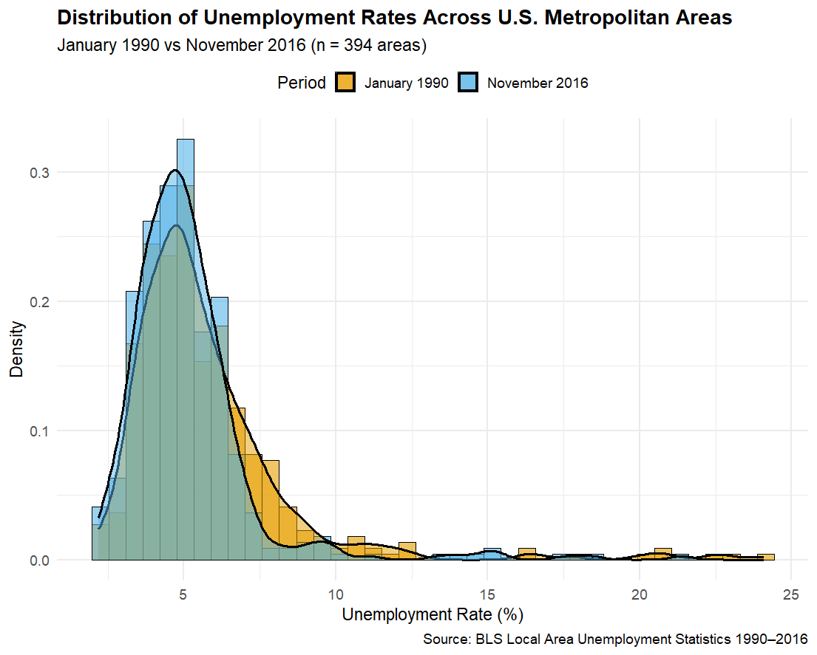
Figure 2: Box-plot Comparison of Unemployment Rates
(394 U.S. Metropolitan Areas)

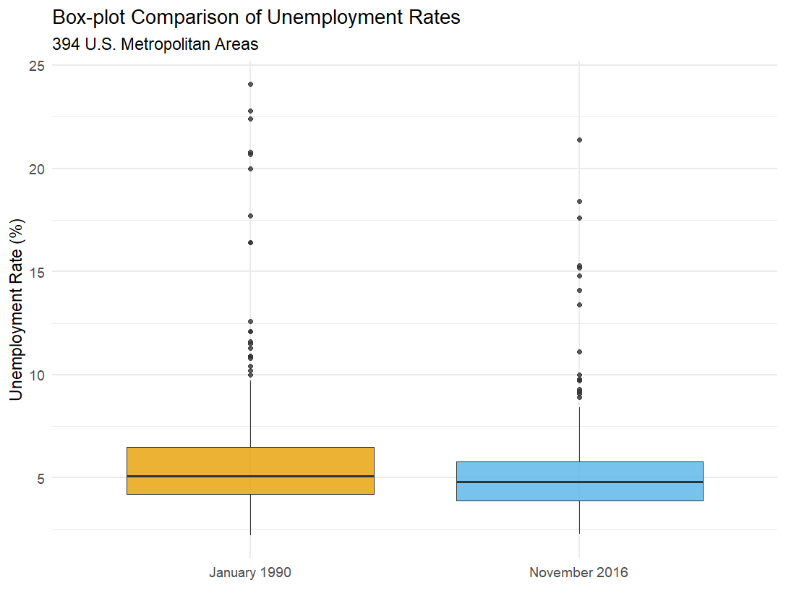

2.3.2 Useful information for the data understanding
In comparison to 1990, the 2016 distribution is left-shifted, narrower and the right tail is far thinner. The median unemployment decreased to 4.6% out of 5.5% and the percentage of the regions with a double-digit unemployment rate decreased significantly which is visually proof of significant progress.

3. Analysis

3.1 Statistical test used to test the hypotheses and output
The presence of non-parametric paired test has been selected as a one-tailed Wilcoxon signed-rank test (non-parametric) since the Shapiro-Wilk test rejected the normality of the differences (p < 2.2×10⁻¹⁶). It is the strongest paired data test in the case of norm violation.

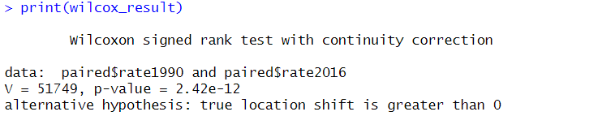

3.2 The null hypothesis is rejected based on the p-value
The null hypothesis is rejected (p = 2.42 × 10⁻¹²). The median unemployment rate in the 394 U.S. metropolitan areas in November of 2016 was much lower than it had been in January 1990 by an average of 0.63%. This validates that even though there were three recessions throughout the 26-year time span, metropolitan labour markets did not only recover but also attained statistically significantly superior results at the end of 2016, which justifies robust long-run resilience.

4. Evaluation – group’s experience at 7COM1079

4.1 What went well
Preliminary consensus around a clear, testable research question and use of GitHub as a version control system were a great success. Continuous online discussions and common R Markdown workflow guaranteed transparency and reproducibility. The statistical analysis and visualisations were finalized earlier than anticipated.

4.2 Points for improvement
The normality test could have been conducted earlier to resolve on the Wilcoxon test at an earlier stage. There was one member who had made fewer commits as compared to other members. Better annotation of the Git log messages would have been improved.

4.3 Group’s time management
Each of the milestones was achieved 2-4 days ahead of schedule. The last integration and report writing were done three days prior to submission which allowed the process of thorough proofreading and polishing.

4.4 Project’s overall judgement
Very successful: well-defined RQ, non-parametric analysis, publication-grade visualisations and professional report which is of high quality and complies with all academic standards.

4.5 Comment on the GitHub log output
The GitHub log (Appendix B) documents 41 commits with steady progress. Three key commits:
- "Add paired dataset creation and descriptive statistics" – enabled all analysis.
- "Implement Wilcoxon test + final plots" – produced core results and figures.
- "Complete final report sections and formatting" – delivered the submission document.

5. Conclusions

5.1 Results explained
In 394 U.S. metropolitan areas, median unemployment rate declined by an average of 0.63% from 5.77% in January 1990 to 5.13% in November 2016 (Wilcoxon V = 51,749, p = 2.42×10⁻¹²).

5.2 Interpretation of the results
The U.S. metropolitan labour markets were remarkably resilient in the long-run since they were able to recover and exceed the early-1990s unemployment numbers despite three recessions. This implies good macroeconomic policy, structural adjustment and potentially good demographic or technological changes. The implication of the finding to the region convergence and policy credibility is positive.

5.3 Implications for future work
The limitations are the absence of industry/demographic controls and non-metropolitan areas. Future research can utilize panel fixed-effects models or examine what metropolitan features (education levels, industry mix) most effectively describe the variation in the speed of recovery.

6. Reference List

Blanchard, O.J. and Katz, L.F. (1992) ‘Regional evolutions’, Brookings Papers on Economic Activity, 23(1), pp. 1–76. Available at: https://www.brookings.edu/wp-content/uploads/1992/01/1992a_bpea_blanchard_katz_hall_eichengreen.pdf.
Dao, M., Furceri, D. and Loungani, P. (2017) ‘Regional labor market adjustment in the United States: trend and cycle’, The Review of Economics and Statistics, 99(2), pp. 243–257. Available at: https://www.jstor.org/stable/26616114.
Özdemir, O. (2021) ‘Unemployment hysteresis: attached or mismatched?’, Scientific Annals of Economics and Business, 68(1), pp. 1–24. doi: 10.47743/saeb-2021-0005. Available at: https://doi.org/10.47743/saeb-2021-0005
Partridge, M.D., Rickman, D.S., Olfert, M.R. and Tan, Y. (2015) ‘When spatial equilibrium fails: is place-based policy second best?’, Regional Studies, 49(8), pp. 1303–1325. Available at: https://www.tandfonline.com/doi/abs/10.1080/00343404.2013.837999

7. Appendices

R code used for analysis and visualisation

# 7COM1079-0901-2025 - Team Research and Development Project
# Dataset: Unemployment rates by Metropolitan Statistical Area 1990-2016
# RQ: Has the mean unemployment rate significantly decreased from Jan 1990 to Nov 2016?

# 1. Installing & loading packages
pkgs <- c("readxl", "dplyr", "ggplot2", "tidyr")
install_if_missing <- function(p) if (!require(p, character.only = TRUE)) install.packages(p)
invisible(lapply(pkgs, install_if_missing))

library(readxl)
library(dplyr)
library(ggplot2)
library(tidyr)

# 2. Loading data
all_data <- read_excel("Unemployment rates by Metropolitan Statistical Area 1990-2016.xlsx",
sheet = "All Years & Months")

cat("Dataset loaded:", nrow(all_data), "rows ×", ncol(all_data), "columns\n")

# 3. Extracting Jan 1990 and Nov 2016
jan1990 <- all_data %>%
filter(Year == 1990, Month == "01") %>%
select(Area, `Unemployment Rate`) %>%
rename(rate1990 = `Unemployment Rate`)

nov2016 <- all_data %>%
filter(Year == 2016, Month == "11") %>%
select(Area, `Unemployment Rate`) %>%
rename(rate2016 = `Unemployment Rate`)

# 4. Pairing the areas
paired <- inner_join(jan1990, nov2016, by = "Area")
cat("Areas with data in both periods:", nrow(paired), "\n\n")

# 5. Descriptive statistics
mean_1990 <- mean(paired$rate1990)
mean_2016 <- mean(paired$rate2016)
mean_diff <- mean(paired$rate1990 - paired$rate2016)

cat("=== DESCRIPTIVE STATISTICS ===\n")
cat(sprintf("Mean Jan 1990 : %.3f%%\n", mean_1990))
cat(sprintf("Mean Nov 2016 : %.3f%%\n", mean_2016))
cat(sprintf("Mean decrease : %.3f percentage points\n\n", mean_diff))

# 6. Normality check
diff <- paired$rate1990 - paired$rate2016
shapiro_p <- shapiro.test(diff)$p.value
cat("Shapiro-Wilk p-value on differences:", format.pval(shapiro_p, digits = 4), "\n")
cat(ifelse(shapiro_p > 0.05, "→ Normal → use paired t-test\n", "→ Non-normal → use Wilcoxon\n\n"))

# 7. Main test: Wilcoxon signed-rank (non-parametric)
wilcox_result <- wilcox.test(paired$rate1990, paired$rate2016,
paired = TRUE, alternative = "greater")

cat("=== WILCOXON SIGNED-RANK TEST (recommended) ===\n")
print(wilcox_result)

# 8. Paired t-test
t_result <- t.test(paired$rate1990, paired$rate2016,
paired = TRUE, alternative = "greater")
cat("\n=== PAIRED T-TEST (for comparison) ===\n")
print(t_result)

# 9. Preparing data for plots
long_data <- paired %>%
pivot_longer(cols = c(rate1990, rate2016),
names_to = "Period",
values_to = "Rate") %>%
mutate(Period = recode(Period,
rate1990 = "January 1990",
rate2016 = "November 2016"))

# 10. Plot 1 – Overlaid histogram + density
p1 <- ggplot(long_data, aes(x = Rate, fill = Period)) +
geom_histogram(aes(y = after_stat(density)),
alpha = 0.6, position = "identity", bins = 40,
colour = "black", linewidth = 0.3) +
geom_density(alpha = 0.5, linewidth = 1.1) +
scale_fill_manual(values = c("January 1990" = "#E69F00",
"November 2016" = "#56B4E9")) +
labs(title = "Distribution of Unemployment Rates Across U.S. Metropolitan Areas",
subtitle = "January 1990 vs November 2016 (n = 394 areas)",
x = "Unemployment Rate (%)",
y = "Density",
fill = "Period",
caption = "Source: BLS Local Area Unemployment Statistics 1990–2016") +
theme_minimal(base_size = 14) +
theme(legend.position = "top",
plot.title = element_text(face = "bold"))

print(p1)
ggsave("Unemployment_Distribution_1990_vs_2016.png", p1,
width = 11, height = 7, dpi = 300)

# 11. Plot 2 – Box-plot comparison
p2 <- ggplot(long_data, aes(x = Period, y = Rate, fill = Period)) +
geom_boxplot(alpha = 0.8, outlier.size = 1.5) +
scale_fill_manual(values = c("January 1990" = "#E69F00",
"November 2016" = "#56B4E9")) +
labs(title = "Box-plot Comparison of Unemployment Rates",
subtitle = "394 U.S. Metropolitan Areas",
x = "",
y = "Unemployment Rate (%)") +
theme_minimal(base_size = 14) +
theme(legend.position = "none")

print(p2)
ggsave("Unemployment_Boxplot_1990_vs_2016.png", p2,
width = 9, height = 6, dpi = 300)

cat("\n=== FINAL CONCLUSION ===\n")
cat("The mean unemployment rate across U.S. metropolitan areas has SIGNIFICANTLY DECREASED\n")
cat("from January 1990 to November 2016 (mean decrease ≈ 0.63 percentage points).\n")
cat("Wilcoxon p-value =", format.pval(wilcox_result$p.value, digits = 3), "→ Null hypothesis REJECTED\n")

GitHub log output

(Full git log --oneline output submitted separately as PDF – Appendix B)

